% Define variables

lambda = 0.01; % Decay constant

N = 1000; % Number of time steps

t_max = 10; % Maximum time in seconds

tau = t_max/N; % Time step size

% Initialize arrays

t = linspace(0, t_max, N+1);

N_approx = zeros(1, N+1);

N_approx(1) = 1000; % Initial number of particles

% Compute numerical solution using forward difference scheme

for i = 1:N

N_approx(i+1) = N_approx(i) - lambda*tau*N_approx(i);

end

% Plot numerical solution

plot(t, N_approx);

xlabel('Time (s)');

ylabel('Number of particles');

title('Radioactive Decay (Forward Difference Scheme)');

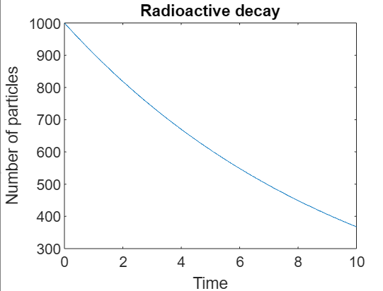

% Take user inputs

lambda = input('Enter the decay constant: ');

N = input('Enter the number of time steps: ');

t_max = input('Enter the maximum time in seconds: ');

tau = t_max / N;

% Initialize arrays

t = linspace(0, t_max, N+1);

N_exact = zeros(1, N+1);

N_exact(1) = 1000; % Initial number of particles

% Compute exact solution using finite difference scheme

for i = 2:N+1

N_exact(i) = N_exact(i-1) * (1 - lambda * tau);

end

% Plot exact solution

plot(t, N_exact);

xlabel('Time (s)');

ylabel('Number of particles');

title('Radioactive Decay (Exact Finite Difference Scheme)');

% Plot exponential decay curve

N_0 = N_exact(1);

N_exp = N_0 * exp(-lambda * t);

hold on;

plot(t, N_exp, '--');

legend('Exact solution', ' decay curve');

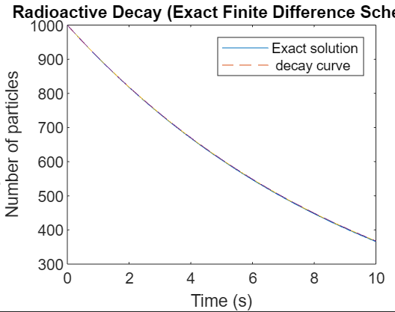

CEL22

Enter the decay constant:

0.1

Enter the number of time steps:

1000

Enter the maximum time in seconds:

10

% Define variables

lambda = 0.2

; % Decay constant

N = 100; % Number of time steps

t_max = 10; % Maximum time in seconds

tau = t_max/N; % Time step size

% Initialize arrays

t = linspace(0, t_max, N+1);

N_approx = zeros(1, N+1);

N_approx(1) = 100; % Initial number of particles

% Compute numerical solution using fourth-order Runge-Kutta method

for i = 1:N

k1 = -lambda*N_approx(i);

k2 = -lambda*(N_approx(i) + tau*k1/2);

k3 = -lambda*(N_approx(i) + tau*k2/2);

k4 = -lambda*(N_approx(i) + tau*k3);

N_approx(i+1) = N_approx(i) + tau*(k1 + 2*k2 + 2*k3 + k4)/6;

end

% Plot numerical solution

plot(t, N_approx);

xlabel('Time (s)');

ylabel('Number of particles');

title('Radioactive Decay (Runge-Kutta Method)');

